**Banaba Health Care Center Mobile Monitoring Application**

A Project

Presented to the Faculty of College of Informatics and Computing Sciences

BATANGAS STATE UNIVERSITY:

The National Engineering University

Alangilan, Batangas City

In Partial Fulfillment of the Requirements for the Degree

**Bachelor of Science in Information Technology**

**Major in Service Management**

By:

Marasigan, Jack-Son C.

Luengas, Paul Angelo B.

Almarez, Jake

Submitted to:

Niña Veronica Fragada

Arjonel Mendoza

July 2023

**PROJECT DESCRIPTION**

The health center is critical in ensuring that people have a reliable health care center and can appropriately manage their medical records effectively. It must assess individual needs to investigate and comprehend the patient's privacy needs. The purpose of the health center process is to give patients immediate and dependable healthcare services in a secure and efficient manner, all while protecting data privacy and maintaining the availability of the organization process. It provides health services that help in maintaining the health of community members, satisfying the provision of "Good Health and Well-Being." Depending on the type of health center and the services provided, the steps of the health center procedure may differ.

An application designed to ensure that Barangay Health Worker (BHW) find the application worthwhile and dependable. As it is beneficial to have an application in their organization, they can also obtain such information as is required for their needs, particularly when it comes to health. It can manage and assist in data inconsistency while enhancing data recording consistency.

Data consistency is essential because it ensures that the data is dependable and correct, and that it can be relied on to support decision-making and other business operations. If the input is inconsistent, inefficiencies, and other issues that affect the performance of the health center.

**DEVELOPMENT MODEL**

**Agile Methodology**

The development of a model is an iterative process multiple models are built, tested, and improved upon before a model that meets the requisite requirements is established. For later modeling work, it may be required to begin the search where the first model building began rather than where it ended. The researcher selected to use the Agile Development technique as a guide when constructing the application to accomplish the study's objectives.

***Figure 1. Agile Methodology***

Figure 1 illustrates the Agile Model and includes phases like the planning, design, analysis, implementation, and development. The developers used this kind of model mainly because of its flexibility. This model allows changes within a short period of time and adjustments to changing demands. The agile methodology provided a better and more stable application, made the client more involved, and distinguished what works and not. Because of that, the developers focused on a specific set of tasks while considering the task's importance. The development model includes planning, design, analysis, implementation, and development.

**Planning**

It involves the identification of the range of the development and the contents to be included that was decided as important data to add. How the development will be executed and distribution of the tasks.

**Design**

In this stage the team brainstorms the UI of the application while considering the required components that it has to have baked on the purpose of the application for the user. The UI doesn’t need to be fancy depending on the type of application that was being developed. In the end of the process the team must have an out of wireframe and mock-up design to be the reference of the development of the application structures.

**Analysis**

In this phase the team needs more information about what aspect of development you are referring to. It also evaluates the process of the organization to match with the workflow of the application upon development. It was a process that helped ensure that the app was being developed, meets their needs and goals, and is delivered on time.

**Development**

As obtaining a strong understanding of the organization. The development includes developing a project plan, managing project risks, and communicating effectively with stakeholders throughout the development process.

**Implementation**

The implementation will show the effectiveness of the application and if it meets the objective of the project.

**SYSTEM ARCHITECTURE**

**Sequence Diagram**

The representation of interaction between entities along with the application was illustrated on Figure 2 which showed the sequence diagram of the application. Sequence diagram is a type of UML diagram that shows how objects in an application or classes within code interact with each other.

***Figure 2. Sequence Diagram***

These diagrams depict interactions in the order in which they depict the chain of events. Researchers use it to document processes or to comprehend the needs of a new software. Typically made up of objects and actors who initiate and respond to messages from one another. The sequence diagram has one actor in total, the Banaba Health Workers (BHW). Only after the patient completes the form for a patient enrollment or health care request that will be recorded by the BHW to the application. After logging in, the BHW will have access to the application various functions to manage the patient and medicine information, as well as edit information on the application.

**Use Case**

It is a specific situation in which a product or service might be utilized. This is an example of an explanation of how a user of that application or process would approach obtaining a specific goal. Although it is most associated with application, it can also refer to any process. A use case allows you to identify potential process flaws and develop solutions to overcome them. It is a written explanation of how users will use your website to fulfill tasks. It describes how an application responds to a request from the perspective of a user. Each use case is depicted as a simple series of events that begin with the user's goal and ends when it is accomplished.

***Figure 3. Use Case Diagram***

Figure 3 is a use case diagram that depicts a summary of the actors' and the application’s interaction, including its features and cases. This diagram did not depict the proper sequence of events in the application. The use case diagram of the established application was discussed here, as well as the specifics for the actors, which were the Barangay Health Workers (BHW) and patients. Based on the information provided, the patient was able to provide their information to the Barangay Health Workers (BHW) through the forms given by the BHW. To maintain data security, only BHW are permitted to manage patient information, provide reports, and supervise the schedule.

**GITHUB REPOSITORY**

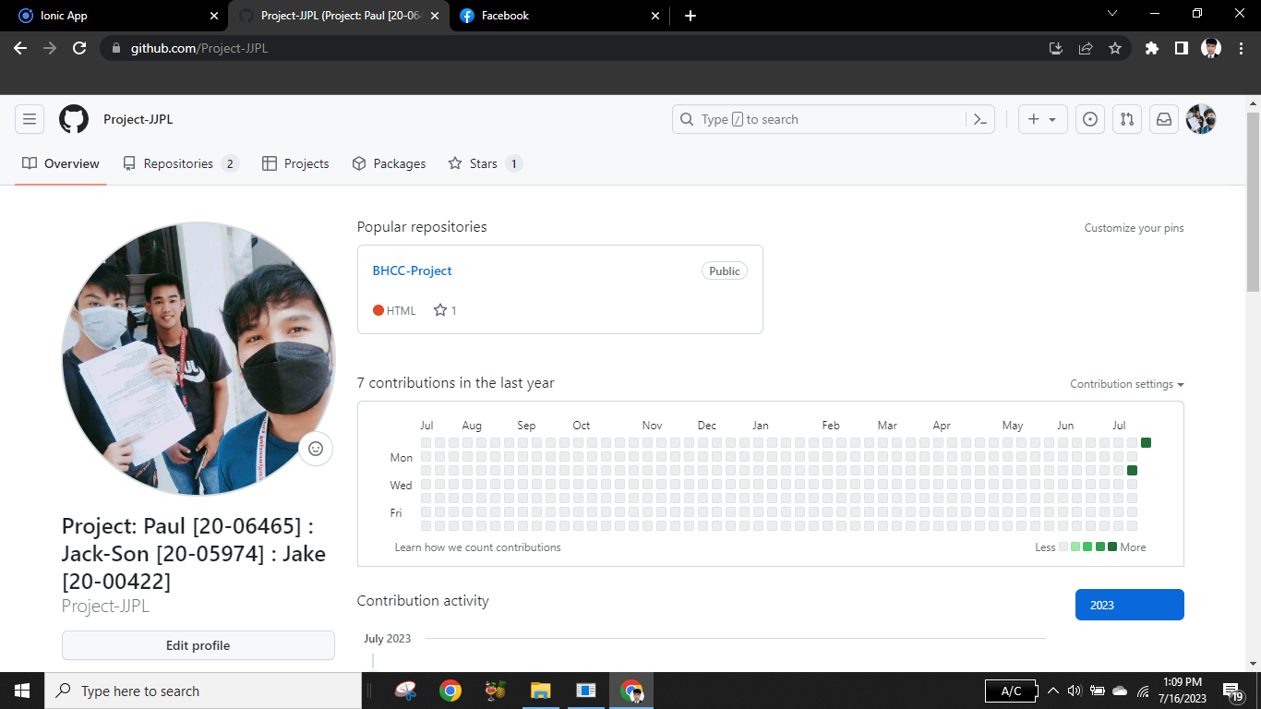

**

**TEAM MEMBERS**

**Marasigan, Jack-Son**

The project manager that is responsible for the project planning. Provide updates on the project’s progress and escalate any concern that arises. Assigning project tasks and setting deadlines. Generates new ideas for the project. Responsible for monitoring the progress of the development. Assigned as project designer that provides suggestions and development of the application front end design. Edit picture, diagram, and paper for the project. Help the researcher for the completion of the task. Has a role as a researcher providing project documentation. Collect, review, and analyze the data. Search for the data that can contribute to the project documentation.

**Luengas, Paul Angelo**

The main programmer that creates, reviews, analyzes, and manages codes. Update existing codes and identify errors. Run a test for the application/ troubleshoot problems. Collaborate with the Designer, Project Manager, Researcher, and Contact Person. The researcher for the completion of the task. Has a role as a researcher providing project documentation. Collect, review, and analyze the data. Search for the data that can contribute to the project documentation.

**Almarez, Jake**

The researcher for the completion of the task. Has a role as a researcher providing project documentation. Collect, review, and analyze the data. Search for the data that can contribute to the project documentation.